**A PROJECT BASED LEARNING REPORT**

**ON**

**RAILWAY RESERVATION SYSTEM**

**IN**

**DATABASE MANAGEMENT SYSTEM LAB**

**Bachelor of Technology**

**(Department of Information Technology)**

**Based on: PYTHON , MySQL**

**SUBMITTED BY: EKANSH MISHRA(189713043)**

**ASHISH KUMAR SHARMA(1809713025)**

**ARYA TYAGI(1809713022)**

**ASHISH ASTHANA(1809713024)**

**UNDER THE GUIDANCE OF: MR.GAGAN GUPTA**

**GALGOTIAS COLLEGE OF ENGINEEING AND TECHNOLOGY**

**GREATER NOIDA**



**Affiliated to:**

**DR. A.P.J. Abdul Kalam Technical University(A.K.T.U)**

**Lucknow, Uttar Pradesh.**

**TABLE OF CONTENTS**

1. INTRODUCTION……………………………………………………… P-3
2. OVERALL DESCRIPTION …………………………………………… P-4
3. SPECIFIC REQUIREMENT…………………………………………….. P-6
4. DESIGN ……………..………………………………………………….. P-10
5. IMPLEMENTATION…………………………………………………… P-12
6. RESULT AND CONCLUSION………………………………………… P-26
7. REFERENCES………………………………………………………….. P-26

**INTRODUCTION**

The main aim of developing this system is to provide an easy but secure portal to the people where people can get all the benifits of railway reservation .With this application users can freely plan their journey days ahead and with the cancel window easily cancel the tickets when needed.The administrator window allows the admin to get all the result on application and the query function allows admin to directly execute the sql queries in the allication itself which is extremly handy tool and powerful tool.

The present project elucidates the following features.

1. Registering the new users

2. Reset window to reset login credential

3. Search trains

4. Book ticket

5. Cancel ticket

6. Get PNR status

7. View account details

8. Admin window

**OVERALL DESCRIPTION**

We have developed a Railway Reservation System in which we can plan our journey, check trains running between system, book tickets, check PNR status, cancel tickets and many more. The user first has to create an account by signing up to our Railway Reservation System and then the user can enjoy the facilities we have provided in the system. We have tried our best to make this software the one and only stop for anyone who is planning to travel by train.

The graphical user interface we have developed for this Reservation System makes it very easy to navigate software for anyone. Our whole GUI is built using Python 3, and we have tried to make it as user friendly as possible.

We have also included the necessary security feature in our system by requiring every user to login using his unique User name and password. The data entered by any user during login is matched against the database we have created containing all the user information.

In our software we have provided

* User Signup – here user can signup to our software by providing name, email, city, date of birth and sex.
* User Login – Any user who has already signed up can login to his/her account using his Email-ID and password.
* Admin Login – We have also provided login portal to our admins to make it easy for them to make necessary changes in the software with our user-friendly graphical interface.
* Reset Password – Many time it happens that a user forgets his login credentials which make it impossible for the user to get access to his account. To tackle this problem we have provided a ‘Reset Password’ facility to our system by which user can reset his/her password.

We have developed a robust database structure using MySQL. We store the data user provides us during signup and match it against user login details everytime when a user is trying to login in our system. This provides additional security to our system since it prevents any unauthorized user to enter our system

The process of building systems has always been complex with system becoming larger, the costs and complexities get multiplied. Since we have provided multiple facitilities in system, the need for better methods for developing systems are widely used in our system to make it effective and efficient.

**SPECIFIC REQUIREMENTS**

Software Environment is a technical specification of requirement of software product. This specifies the environment for development, operation and maintenance of the product.

Technology used:

PYTHON3

SQL

SQL:

The name SQL stands for Structural Query Language. SQL is a data access language, like any other language, it is used for communication. SQL communicates with database manager. The database manager could be Oracle, Informix, DB2 and SQL database. SQL is easy to learn. Despite the fact that SQL is a computer programming language, it is much simpler than traditional programming language like COBOL, BASIC, FORTRAN or API. This is due to the fact that SQL is a non-procedural language.

SQL is one of the Oracle facilities. It is important to understand in each case its differences, purpose and place in the Oracle family.

SQL is the language used to access a relational database, including Oracle.

SQL May be used with each of the Oracle tools, where access to the database is required.

Overview of SQL:

A database management system requires a query language to enable users to access data. Structured Query Language (SQL – pronounced ‘sequel’) is the language used by most relational database systems.

IBM developed the SQL language in a prototype relational database management system –System R – in the mid-1970s. In 1979, Oracle Corporation introduced the first commercially available implementation of SQL.

Features of SQL:

SQL is an English-like language. It uses words such as select, insert, delete as part of its command set.

SQL is a non-procedural language: you specify what information you require, not how to get it. In other words, SQL does not require you to specify the access method to the data. All SQL statements use the query optimizer – a part of the RDBMS – to determine the fastest means of retrieving the specified data. This feature makes it easier for you to concentrate on obtaining the desired result.

SQL processes sets of records rather than a single record at a time. The most common form of a set of records is a table.

A range of user including DBAs, application programmers, management personnel, and many other types of end users can use SQL.

SQL provides commands for a variety of tasks including:

Querying data

Inserting, updating and deleting rows in a table

Creating, modifying and deleting database objects

Controlling access to the database and database objects

Guaranteeing database consistency.

SQL Processing Capabilities:

SQL is composed of a definition language a Data Manipulation Language and a Data Control Language. These three languages support the complete spectrum of Relational Data processing activity. In fact most SQL based product all access to the data through SQL.

1. Data Definition Language:

DDL allows creation, Deletion and Modification of data structure for bar system. These structures include tables, databases and indexes.

Ex: Create, Drop and Alter.

2. Data Manipulation Language:

These commands are used to manipulate the data in tables directly or through views. There are four standard DML statements. They are select, delete, insert and update.

3. Data control language:

These commands are used to control usage and access of data. The most commonly found one’s will include grant, revoke.

Why to Use?

Oracle greatly supports RDBMS features. Also it supports high security to the data and faster accessing capability. It can be run on a variety of platforms and operating systems. One can develop an application easily by providing user-friendly environment.

The features of oracle are portability and compatibility.

PYTHON 3:

Python is an interpreted, object-oriented, high-level programming language with dynamic semantics. Its high-level built in data structures, combined with dynamic typing and dynamic binding, make it very attractive for Rapid Application Development, as well as for use as a scripting or glue language to connect existing components together. Python's simple, easy to learn syntax emphasizes readability and therefore reduces the cost of program maintenance. Python supports modules and packages, which encourages program modularity and code reuse. The Python interpreter and the extensive standard library are available in source or binary form without charge for all major platforms, and can be freely distributed.

Often, programmers fall in love with Python because of the increased productivity it provides. Since there is no compilation step, the edit-test-debug cycle is incredibly fast. Debugging Python programs is easy: a bug or bad input will never cause a segmentation fault. Instead, when the interpreter discovers an error, it raises an exception. When the program doesn't catch the exception, the interpreter prints a stack trace. A source level debugger allows inspection of local and global variables, evaluation of arbitrary expressions, setting breakpoints, stepping through the code a line at a time, and so on. The debugger is written in Python itself, testifying to Python's introspective power. On the other hand, often the quickest way to debug a program is to add a few print statements to the source: the fast edit-test-debug cycle makes this simple approach very effective.

**DESIGN**

ER DIAGRAM-

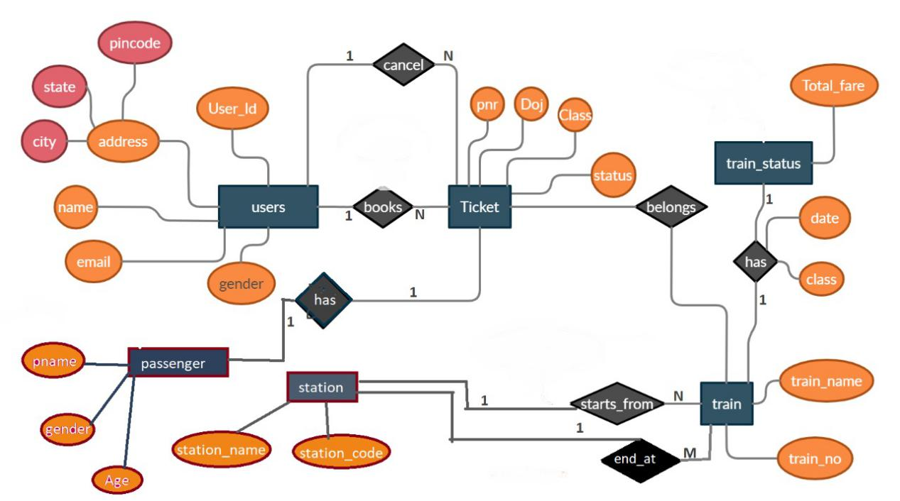

DFDs -

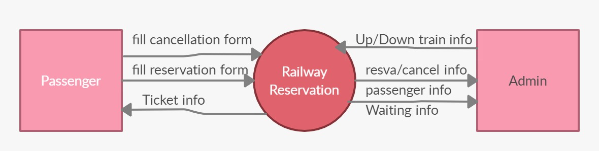

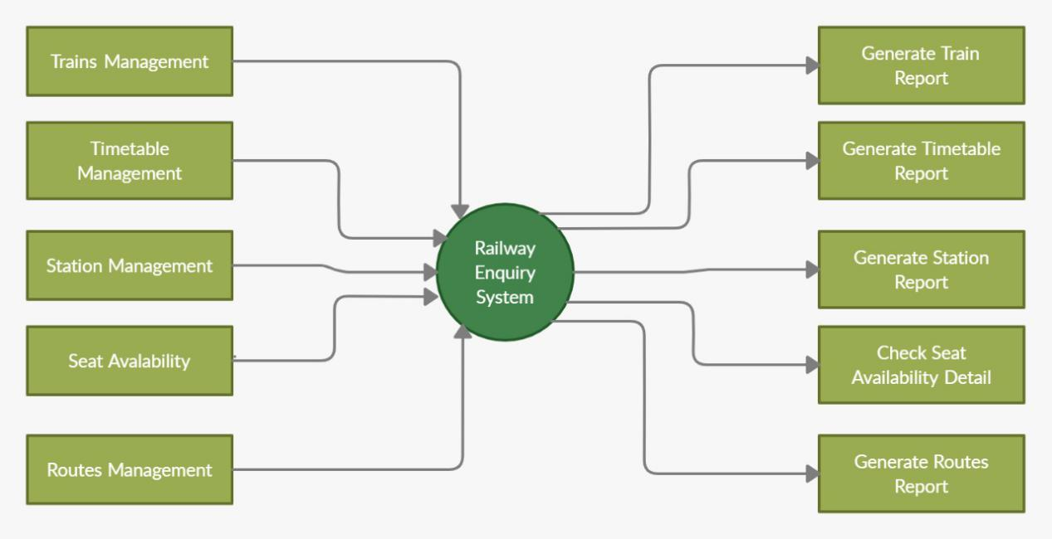

**Implementaion**

First page of application-

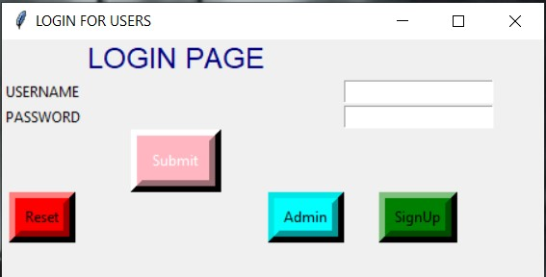

First page on opening of the application is this page which gives us four options

1. Login page for already signed up users
2. SignUp window for new users
3. Reset password link for users who have forgotten their credentials
4. Admin login button

Reset page -

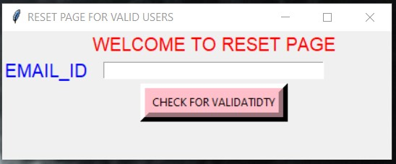

After entering registered user email_id this page checks for validatidty Of it and once confirmed it shows next options

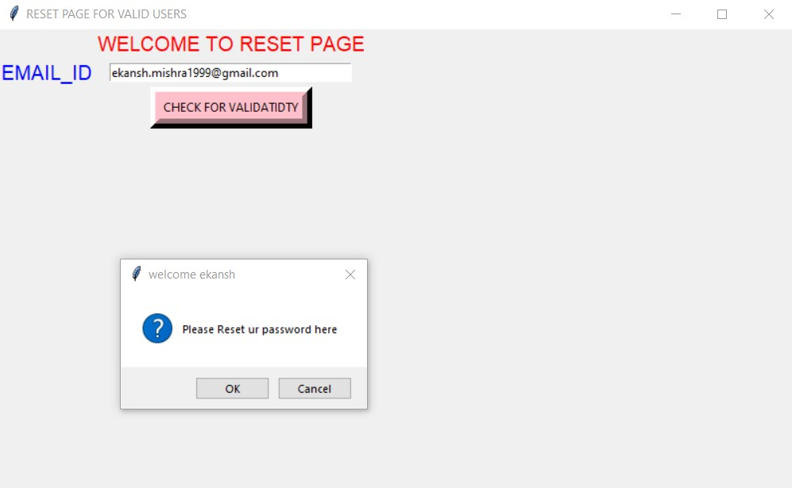

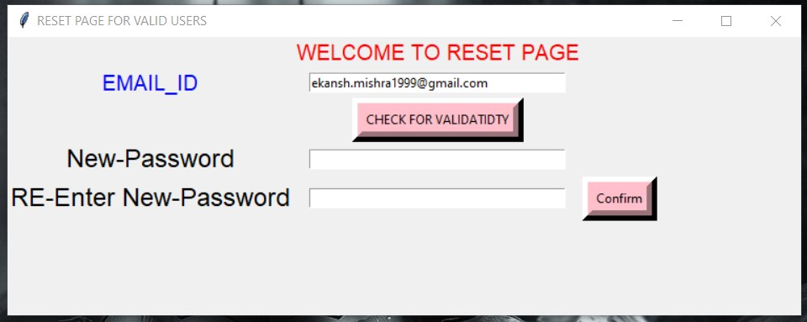

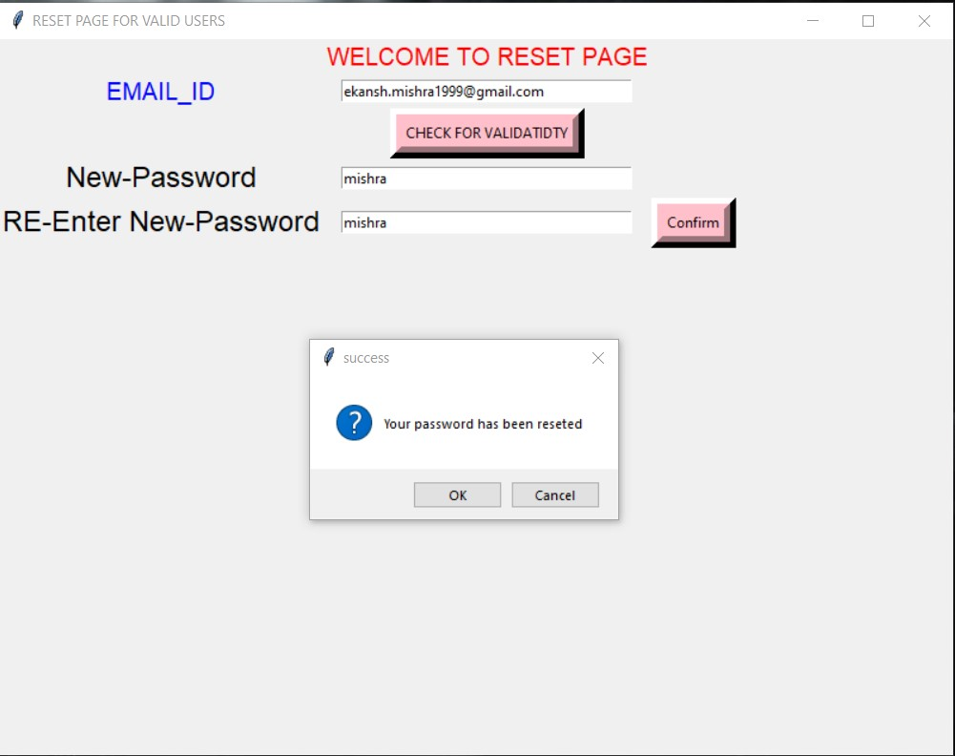

Sign-up window

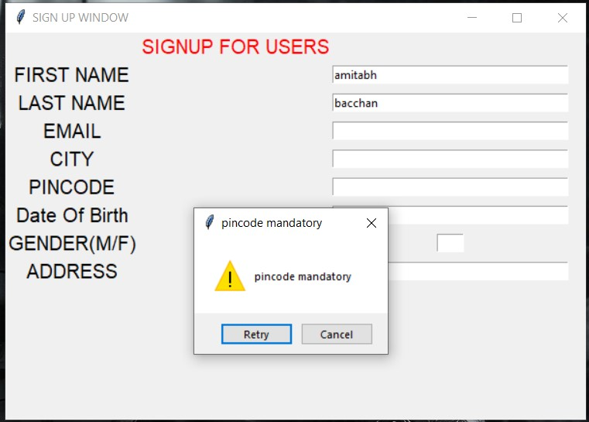

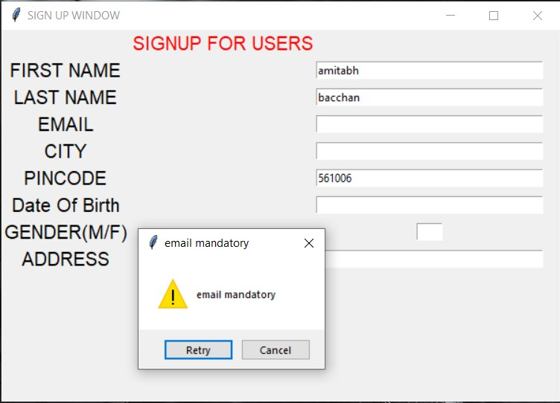

Login Id Creation-

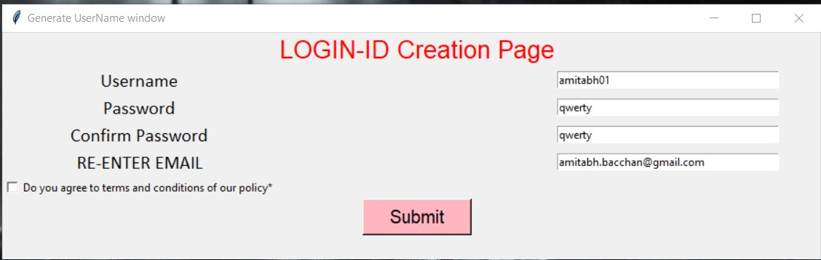

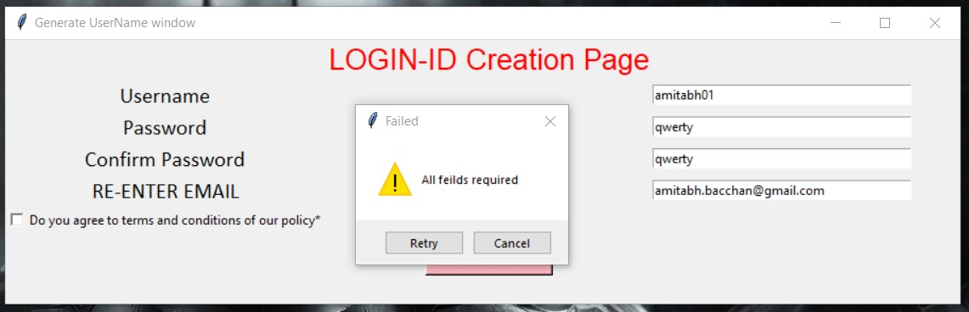

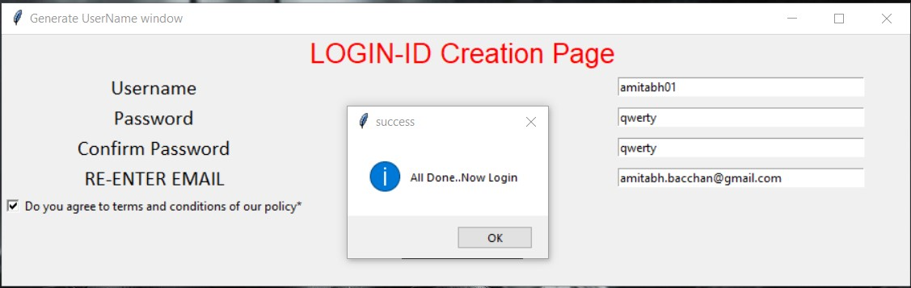

**Admin dashboard**

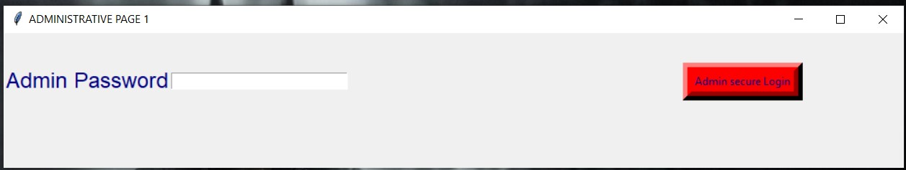

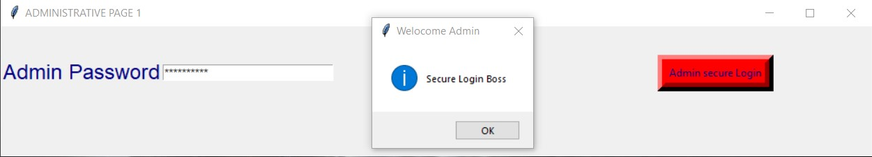

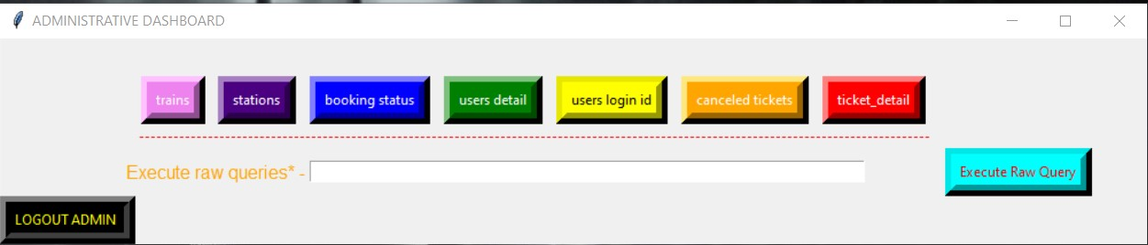

**Login page**

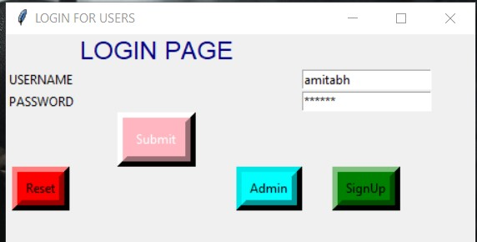

If user is not the first time user and does have a credatial to login can use this option to secure login to his account.Simply by entering username and the password login can be made

Homescreen

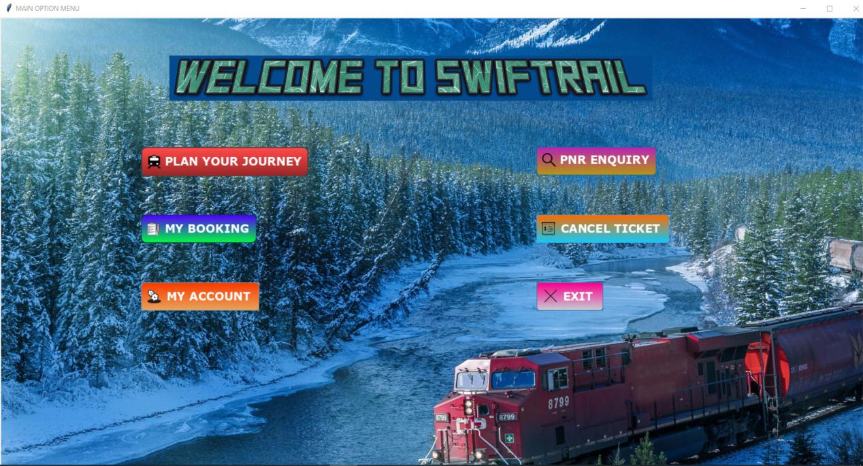

**Plan your journey-**

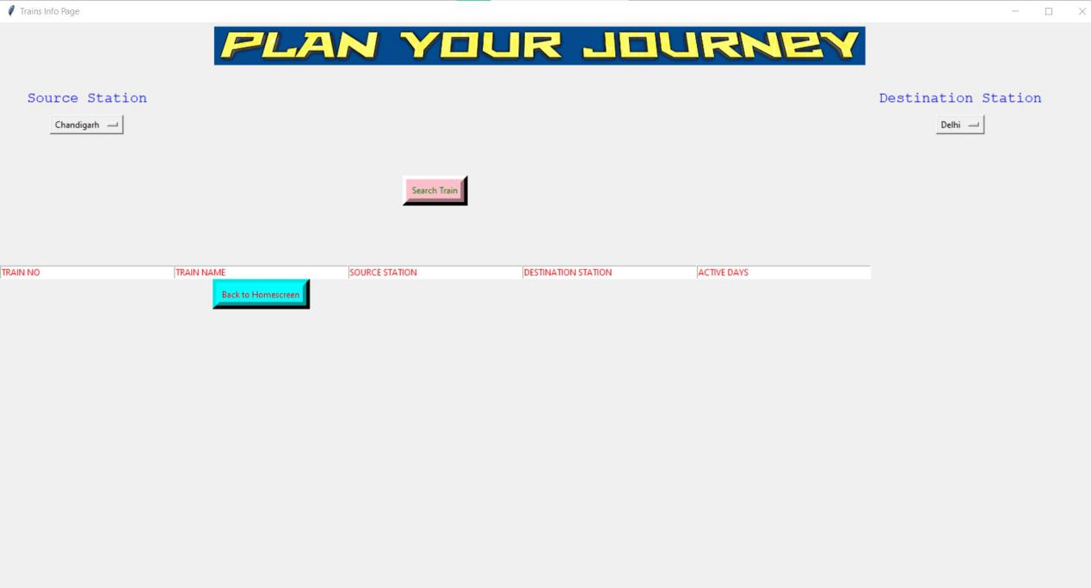

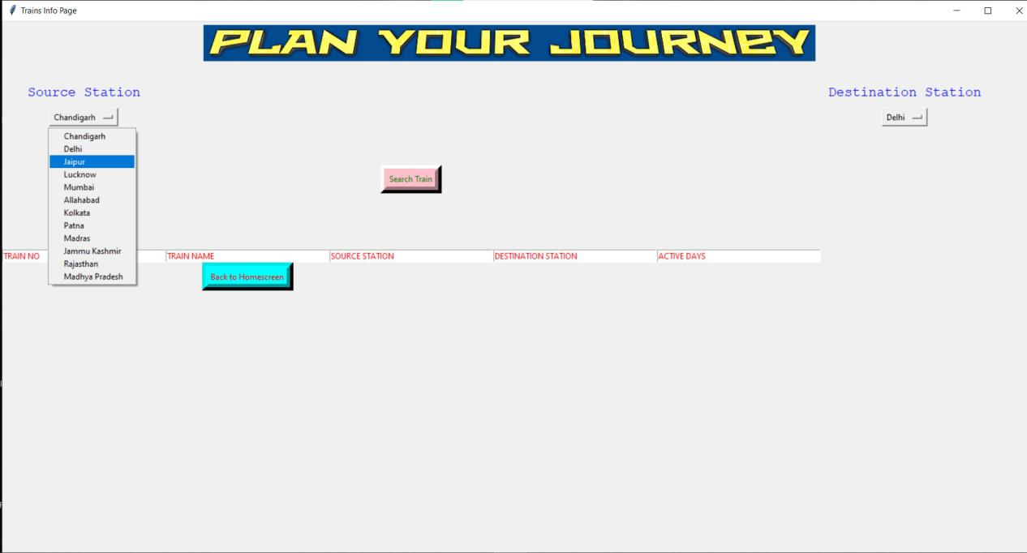

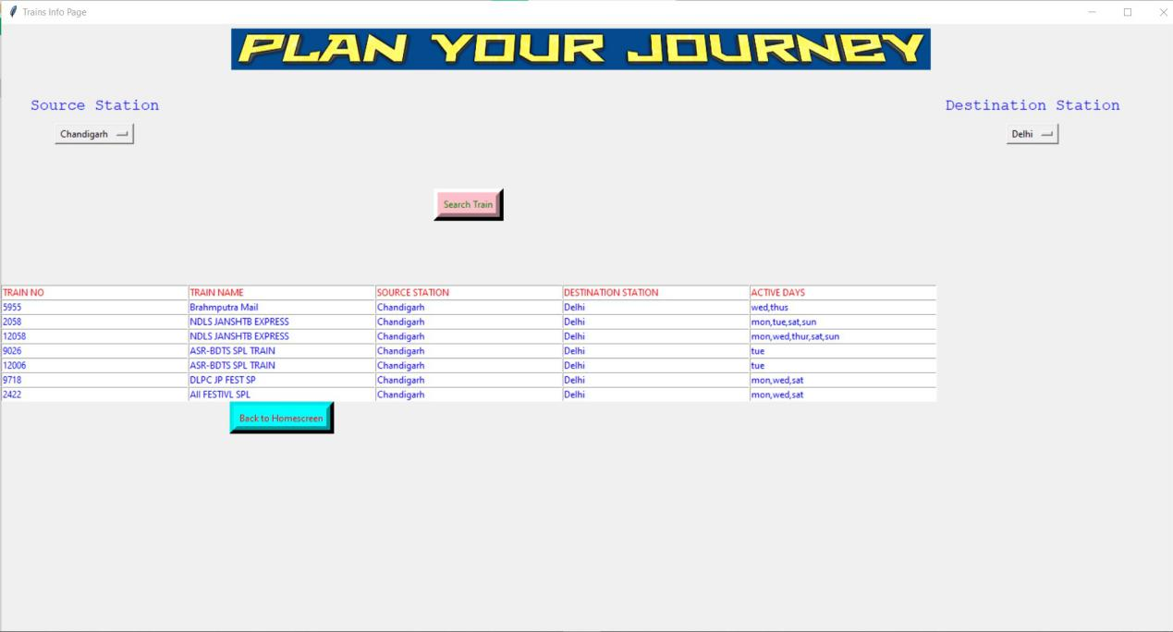

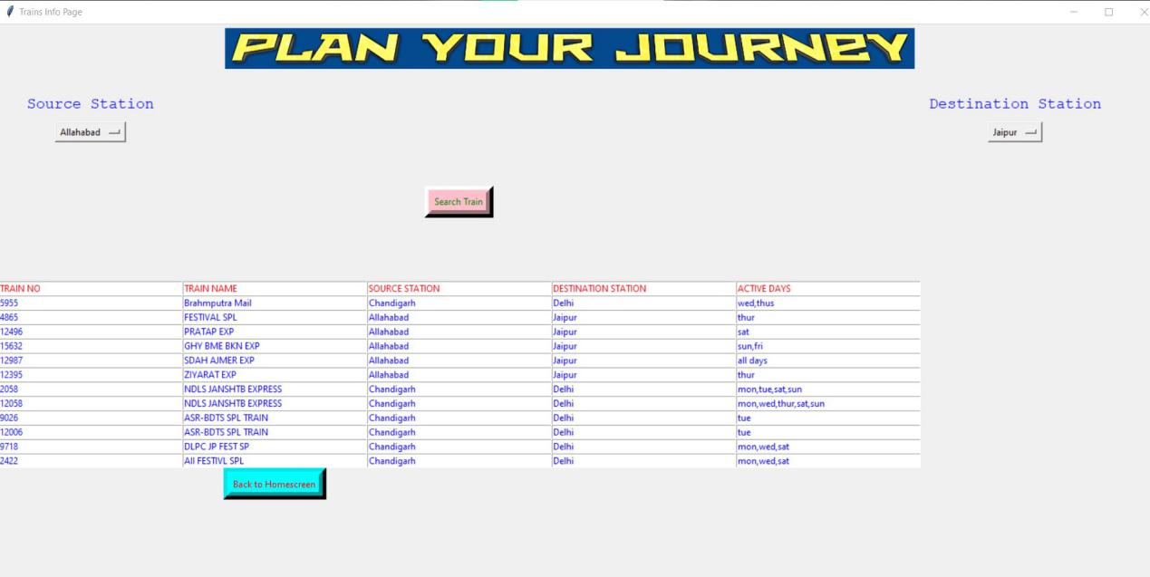

**My Booking Info-**

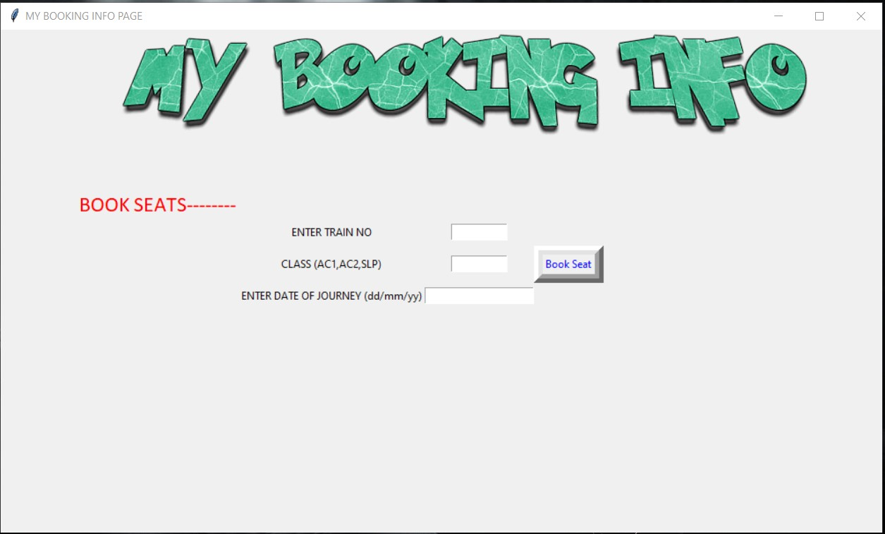

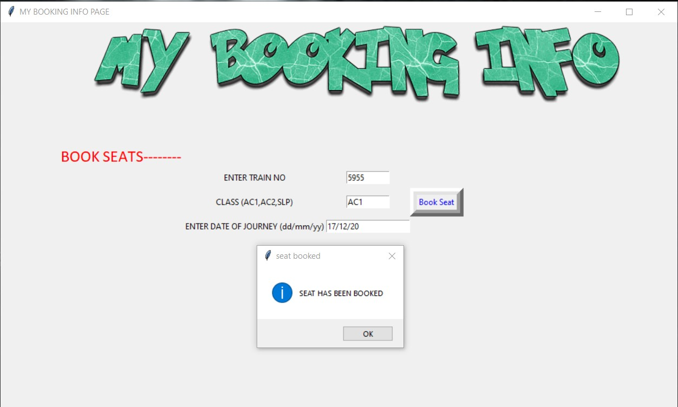

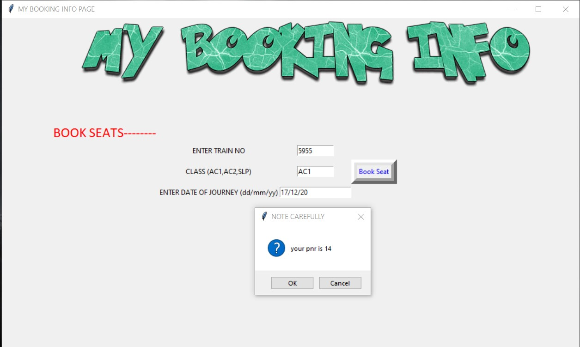

**My Account Information-**

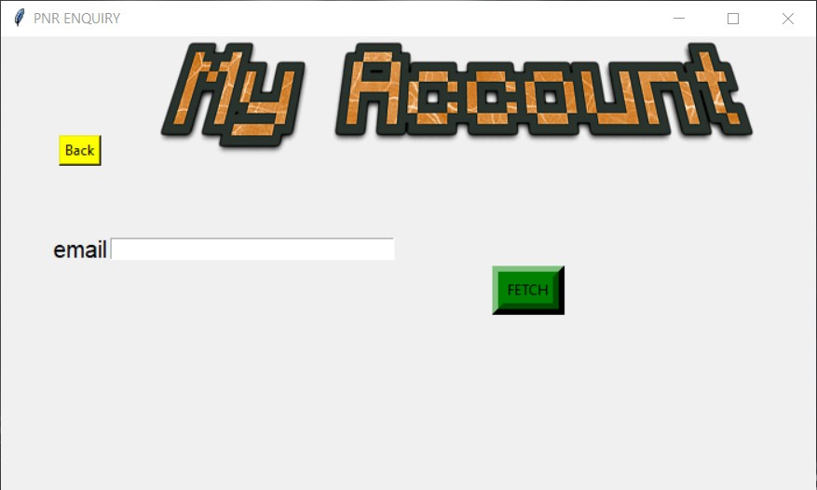

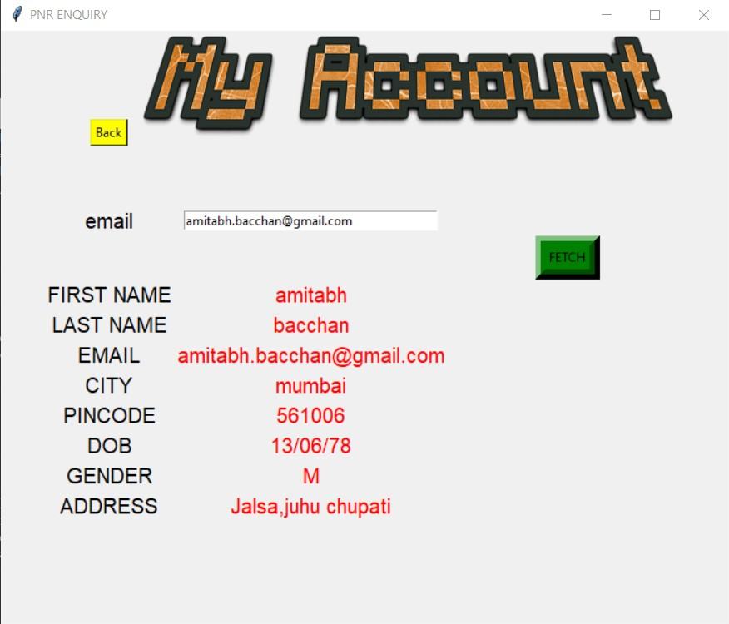

PNR ENQUIRY-

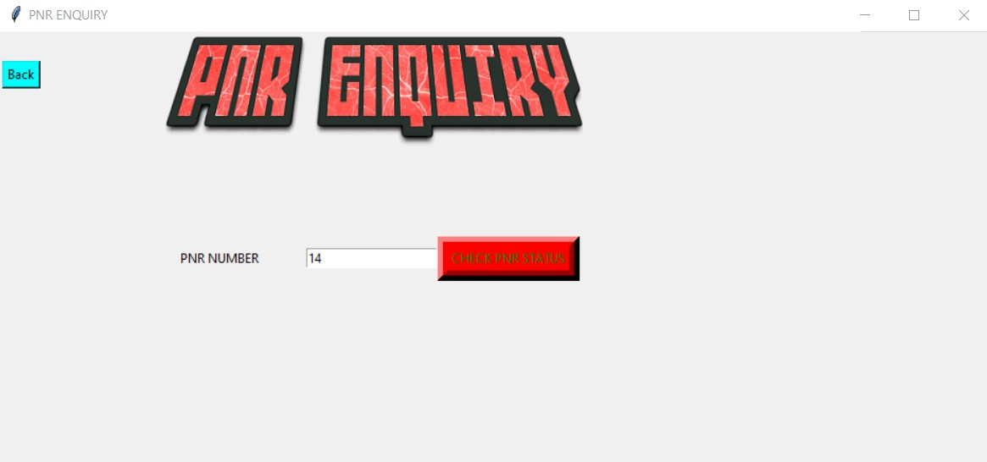

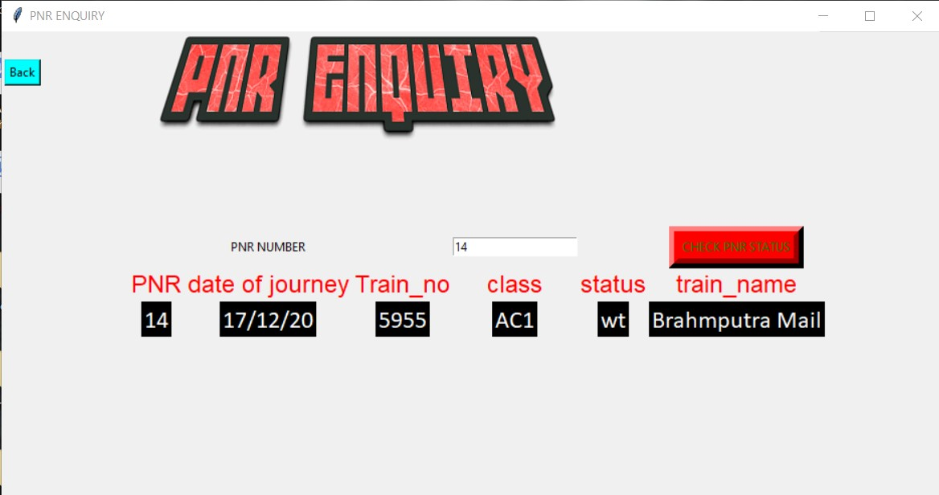

CANCEL TICKET-

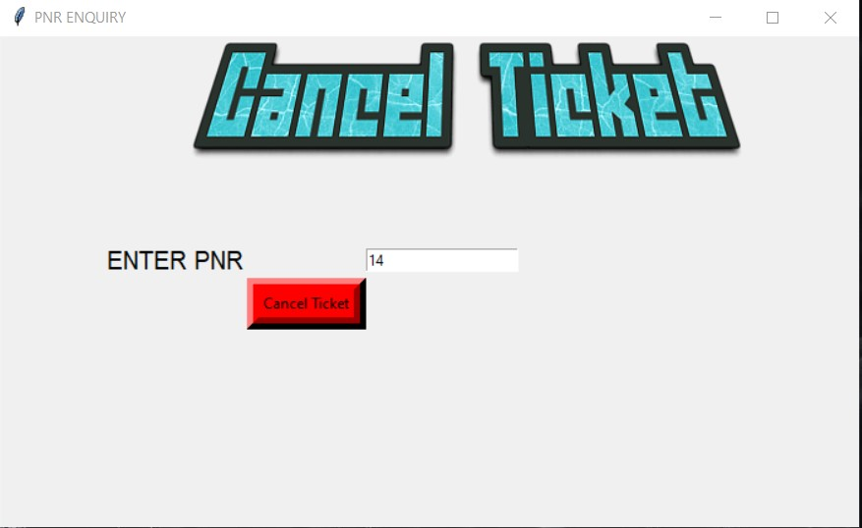

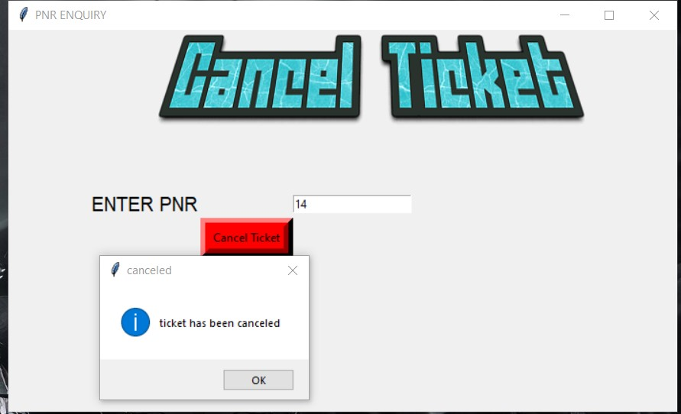

**Result and Conclusion**

Concepts of mysql has been implemented and its integration along with

Python was done successfully. The project showed all the integral components of railway reservation system and were working.

**REFERENCES**

* Sql ddl and dml - <https://www.w3schools.com/sql/>
* Python-https://www.youtube.com/playlist?list=PLCC34OHNcOtoC6GglhF3ncJ5rLwQrLGnV
* [www.google.com](http://www.google.com)/patreon
* [www.irctc.com](http://www.bloodbankservices.com)